**EXCELSSIOR EDUCATION SOCIETY’S**

**K.C. COLLEGE OF ENGINEERING COLLEGE**

**& MANAGEMENT STUDIES & RESEARCH, THANE**

A PROJECT REPORT ON

**“Human Motion Detector”**

SUBMITTED BY:

## Student Name : Awais Mulla

**Student Name : Pranav Karnani**

**Student Name : Adarsh Pandey**

UNDER THE GUIDANCE OF:

### Prof . Shubhangi Wakale



**DEPARTMENT OF INFORMATION TECHNOLOGY**

**K.C. COLLEGE OF ENGINEERING COLLEGE & MANAGEMENT STUDIES & RESEARCH, THANE (2018-2019)**

1

## CERTIFICATE

This is to certify that the project entitled **“Title of project”** is a bonafide work of “Pranav Karnani (22), Awais Mulla (36), Adarsh Pandey (42)”submitted to the University of

Mumbai in partial fulfillment of the requirement for the award of the degree of **“T.E.I.T."** in

**“Internet Of Things”**.

Name and sign Name and sign Name and sign

Guide Head of Department External Examiner

# DECLARATION

We declare that this written submission represents our ideas in our own words and where others' ideas or words have been included, we have adequately cited and referenced the original sources. We also declare that we have adhered to all principles of academic honesty and integrity and have not misrepresented or fabricated or falsified any idea/data/fact/source in my submission. We understand that any violation of the above will be cause for disciplinary action by the Institute and can also evoke penal action from the sources which have thus not been properly cited or from whom proper permission has not been taken when needed.

Name of student and roll no. Signature

1. Pranav Karnani (22)
2. Awais Mulla (36)
3. Adrash Pandey (42)

Date:

# ACKNOWLEDGEMENT

We would like to express special thanks of gratitude to our guide  **Prof. Shubhangi Wakale**  who gave us the golden opportunity to do this wonderful project on the topic of Human Detector System, which also helped us in doing a lot of research and we came to know about so many new things. We would also like to thank our Principal for providing us the opportunity to implement our project. We are really thankful to them. Finally we would also like to thank our parents and friends who helped us a lot in finalizing this project within the limited time frame.

(Name of student and Roll No.)

1. Pranav Karnani (22)

2. Awais Mulla (36)

3. Adrash Pandey (42)

# TABLE OF CONTENT

**Sr.No. Topic Page No.**

Declaration i

Acknowledgement ii

Table of Content iii

List of Figures iv

1. **Introduction………………………………………………………………. 1**
2. **Report on Present Investigation………………………………………… 2** 
   1. Requirement Analysis ………………………………………………….. 3
   2. Problem Statement …………………………………………………….. 6
   3. Project Design………………………………………………………….. 7
3. **Code………………………………………………………………………… 8**
4. **Working & applications……………………………………………………. 10**
5. **Conclusion …………………………………………………………………... 11**

**References……………………………………………………………………… 12**

# LIST OF FIGURES

**Sr. No. Name of figure Page No.**

1. **NodeMCU 3**
2. **Connecting wires 3**
3. **Servo Motor 4**
4. **Smart phone 4**
5. **Arduino 5**
6. **Blynk App 5**
7. **Model Diagram 6**
8. **Block Diagram 7**

**CHAPTER-1**

### INTRODUCTION

Internet of Things represents a general concept for the ability of network devices to sense and collect data from the world around us, and then share that data across the Internet where it can be processed and utilized for various interesting purposes.

Some also use the term industrial Internet interchangeably with IoT. This refers primarily to commercial applications of IoT technology in the world of manufacturing. The Internet of Things is not limited to industrial applications, however.

Surveillance is an important aspect in security, especially with places like banks, jewellery shops and the like. Nowadays even small hotels and bakeries use surveillance systems to protect their properties. Currently there are two types of surveillance system available.

* Passive surveillance system
* Active surveillance system

Now our goal is to built a passive surveillance system that acts as a human detector when the system is fired. The materials required for this purpose have been listed below.

### CHAPTER-2

**Report on Present Investigation**

**2.1**  Requirement Analysis

(Existing Survey, required h/w, s/w requirements, technology used)

**Existing Survey:**

Security being the main intent of the project, the most important application of this system is any domestic security.   
This project can be used at Restaurants, Industries, Manufacturing units, Banks, etc.  
Also, it is very cost-effective.

**Required hardware:**

* PIR Sensor Module
* Arduino UNO (any version)
* LED
* Buzzer
* Breadboard
* Connecting Wires
* 330-ohm resistor

**Required software:**

* Arduino

**Hardware Required:**

* PIR Sensor Module
  1. The [PIR sensor](https://circuitdigest.com/electronic-circuits/pir-sensor-based-motion-detector-sensor-circuit) stands for Passive Infrared sensor. It is a low-cost sensor which can detect the presence of Human beings or animals. There are two important materials present in the sensor one is the pyroelectric crystal which can detect the heat signatures from a living organism (humans/animals) and the other is a Fresnel lenses which can widen the range of the sensor. Also the PIR sensor modules provide us some options to adjust the working of the sensor as shown in below image.

#### FIG 1

The two potentiometers (orange color) are used to control the sensitivity and trigger on time of the sensor. Basically the Dout pin of the sensor is present in between the Vcc and Gnd pins. The module works on 3.3V but can be powered with 5V as well. On the top left corner it also has a trigger pin setup which can be used to make the module work in two different modes. One is the “H” mode and the other is the “I” mode.

In “H” mode the output pin Dout will go high (3.3V) when a person is detected within range and goes low after a particular time (time is set by potentiometer). In this mode the output pin will go high irrespective of whether the person is still present inside the range or has left the area. We are using our module in “H” mode in our project.

In “I” mode the output pin Dout will go high (3.3V) when  a person is detected within range and will stay high as long as he/she stays within the limit of the Sensors range. Once the person has left the area the pin will go low after the particular time which can be set using the potentiometer.

Note: The position of potentiometers or pins may vary based on your PIR sensor vendor. Follow the Silk screen to determine you pinouts

• **Connecting Wires:**

1. 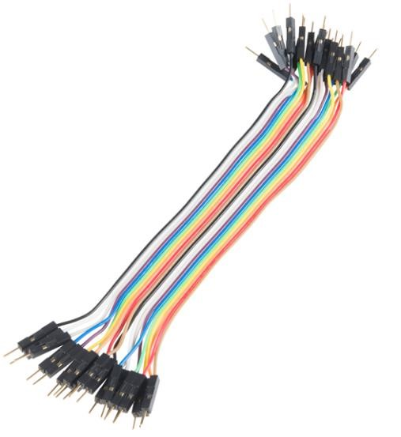Connecting wires allows an electrical current to travel from one point on a circuit to another because electricity needs a medium through which it can move.
2. Most of the connecting wires are made up of copper or aluminum. Copper is cheap and good conducting material.

#### FIG 2

### Light Emitting Diode:

The most common and the coming up electronic component of the 21st Century is LED. Wherever you turn around, you can see an LED. It has a unique character, that it is capable of working on both AC and DC.  Its cheap, light weight, portable and capable of being easily replaceable. Here we have used LED for indication purpose.

**FIG 3** 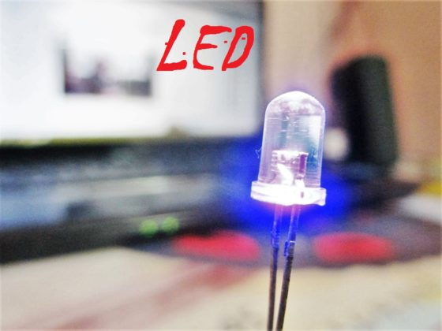

**Software required:**

* **Arduino:**

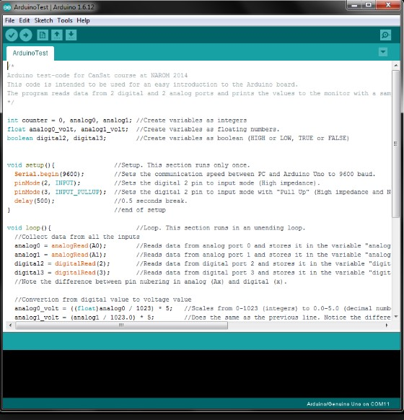

The open source Arduino Software (IDE) makes it easy write code and upload it to the board.

It runs on Windows, Mac OS X, and linux.

The environment is written in java based on processing and other open source software.

This software can be used in any Arduino board.

#### FIG 4

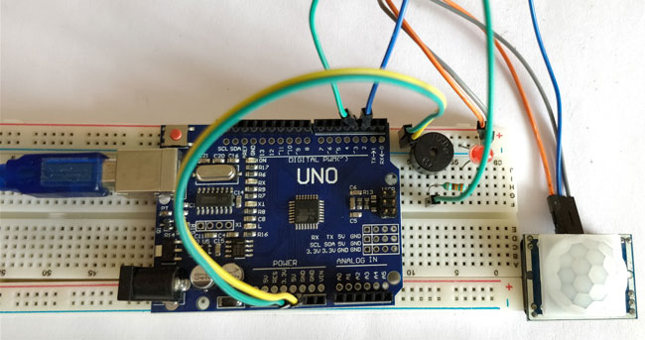

**2.3** Project Design(Block Diagram of Project and related Explanation)

**CHAPTER-3**

#### CODE

void setup() {  
  pinMode(2, INPUT); //Pin 2 as INPUT  
  pinMode(3, OUTPUT); //PIN 3 as OUTPUT  
}

void loop() {  
  if (digitalRead(2) == HIGH)  
  {  
  digitalWrite(3, HIGH);   // turn the LED/Buzz ON  
  delay(100);                       // wait for 100 msecond   
  digitalWrite(3, LOW);   // turn the LED/Buzz OFF  
  delay(100);                       // wait for 100 msecond   
  }  
}

**Working:**

Everytime a human/animal passes by the sensor, the sensor makes a noise & the LED light blinks.

**Applications:**

Concerning the security purpose applications are as follows:

* Office buildings
* Shopping Centres
* Banks
* Server Rooms
* Hotels and Apartments

**Future Scope:**

* We can add more buzzers , so that we can know who has entered.
* We can add a timer so that we can know when the system has detected motion.

### Conclusion

Through this project our knowledge regarding microcontrollers and embedded systems and circuit designing.

We learned about real world applications of microcontrollers and embedded systems.

### REFERENCES

1. Youtube
2. Google
3. Wikipedia
4. IOT Reference books.